Blackjack Design Document

Online Game

01-May-15

Benjamin Umbach, Stoyan Staynov, Popa Vlad

Table of Contents

Architecture diagram 2

Description of Interfaces 2

IPortal 2

Client Class Diagram 3

Server Class Diagram 3

Sequence Diagrams 4

1. Login 4

2. Starting a Game 5

3. Joining a Game 5

4. Inviting a Player to the Game 6

5. Adding Money to the Pool 6

6. Hit 7

7. Stay 7

8. Leaving a Game 8

9. Logout 8

# 

# Architecture diagram

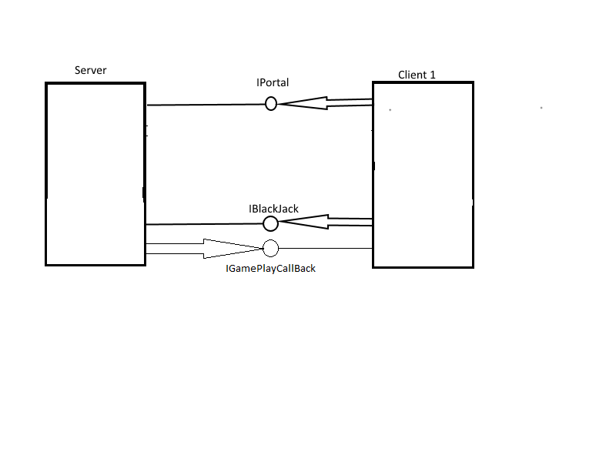

# Description of Interfaces

## IPortal

|  |
| --- |
| <<IPortal>> |
|  |
| +bool logIn(Username,Password)  +void createGame()  +void invitePlayer(string Username)  +void spectateGame(int id)  +void createPrivateGame()  +void SendMessage(string message) |

|  |
| --- |
| <<IBlackjack>> |
|  |
| +void Deal(int amount )  +void Stay()  +bool isWinner() +void SendMessage(string message) |

|  |
| --- |
| <<IGamePlayCallback>> |
|  |
| +void playerTurn(int playerid)  +void playerReady(int playerid)  +void playerBet(int playerid) +void playerChat(string message)  +void playerHit(int playerid)  +void playerStay(playerid)  +void playerInvite(playerid) |

# Client Class Diagram

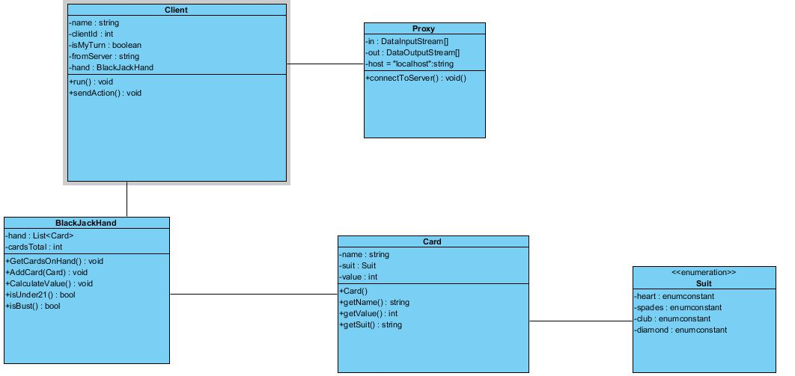

# Server Class Diagram

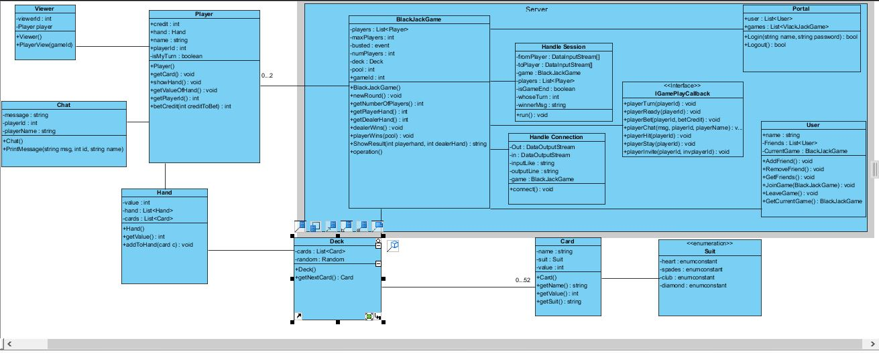

# Sequence Diagrams

## 1. Login

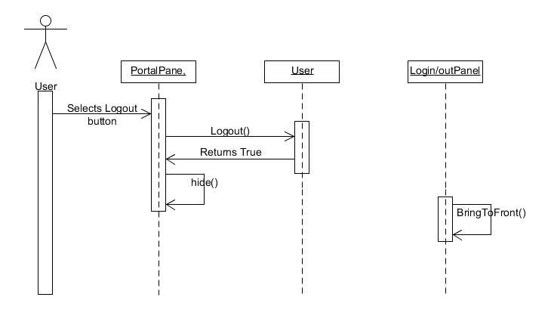

## 2. Starting a Game

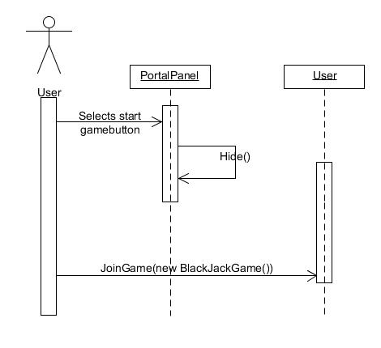

## 3. Joining a Game

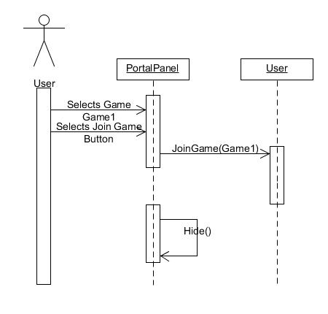

## 4. Inviting a Player to the Game

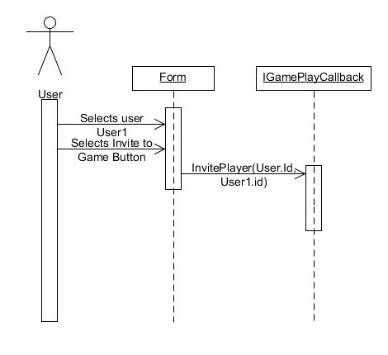

## 5. Adding Money to the Pool

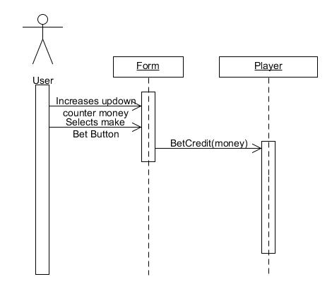

## 6. Hit

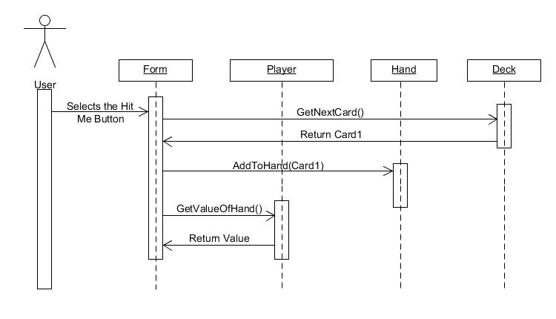

## 7. Stay

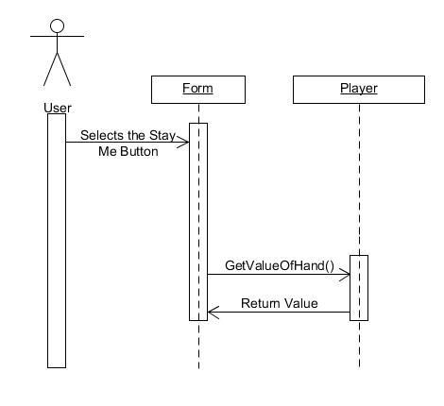

## 8. Leaving a Game

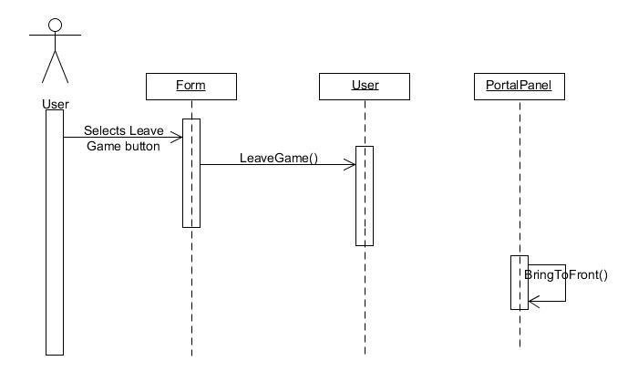

## 9. Logout

